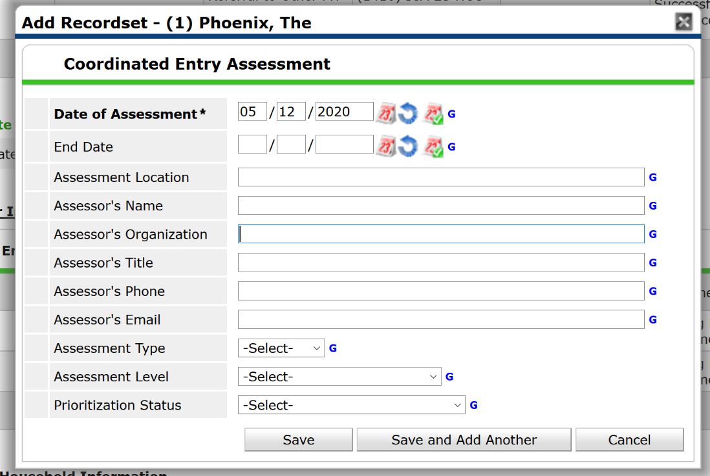

HMIS
Assessor Organization: Full Agency Name & area
Assessor’s Name: Full First & Last Name

List of assessing agencies & corresponding naming convention:
Youthlink
YMCA
The Aliveness Project
St. Stephen’s Human Services – Outreach
St. Stephen’s Human Services – First Covenant
St. Stephen’s Human Services – Clinton
St. Stephen’s Human Services – Next Step
Simpson Housing Services
TSA Harbor Lights Center
Our Saviour’s Housing
People Incorporated – Outreach
MACV
MIWRC
Matrix Housing Services
MoveFwd
Hennepin County – Healthcare for the Homeless
Hennepin County – Homeless Access Team
Hennepin County – Hotels to Housing
Catholic Charities – Hope Street
Catholic Charities – Homeless Elders Program
Avenues for Youth – ConneQT
Avenues for Youth - ES
AICDC
Indigenous Peoples Task Force
Hennepin County- Criminal Justice

CES Connect
Assessor Organization: Full Agency Name

List of assessing agencies & corresponding naming convention:
Domestic Abuse Project
Bridge for Youth
YMCA
Youthlink
St. Stephens Human Services – Next Step
Matrix Housing Services

